UNIT 4 – LAW OF SINES AND COSINES, VECTORS, POLAR GRAPHS

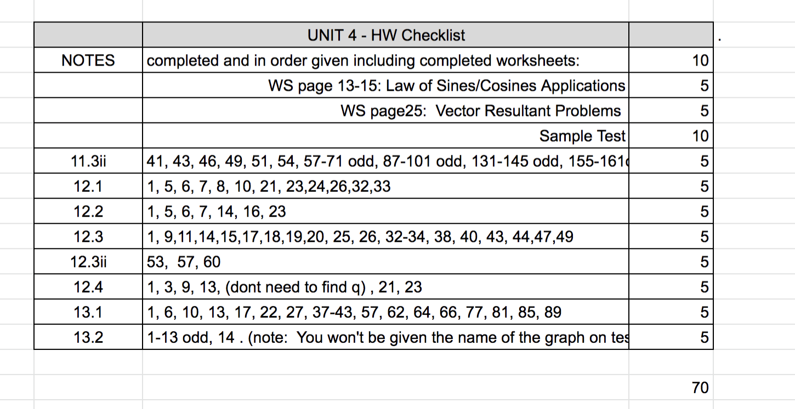

Unit 4– Law of Sines & Cosines, Vectors, Polar Graphs, Parametric Eqns

The next two sections discuss how we can “solve” (find missing parts) of _________________(non-right) triangles.

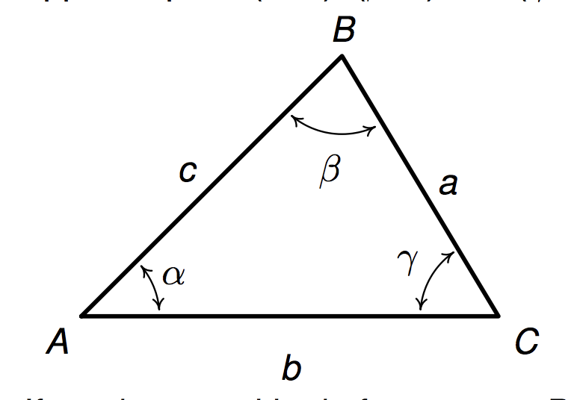

12.1 Law of Sines

If we create right triangles by dropping a perpendicular from B to the side AC, we can use what we know about right triangles to find parts of triangle ABC.

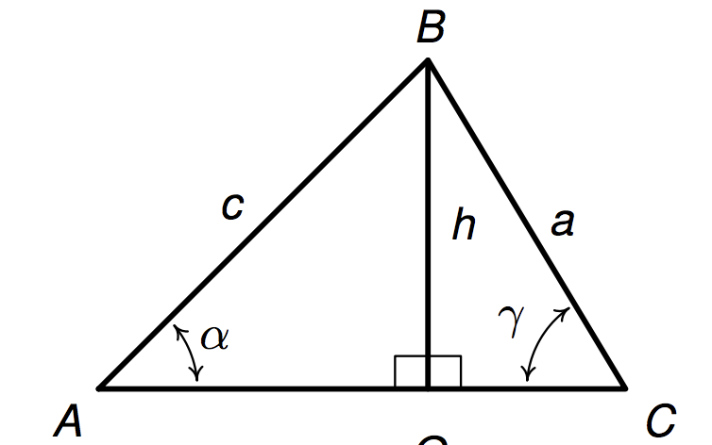

(Book show additional cases/figures.)

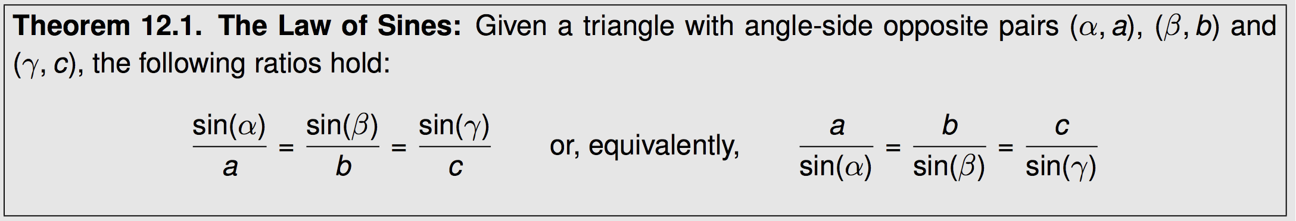

Law of Sines Examples

(I will use the book’s examples here because they are accompanied by useful pictures.)



1)



2) (see book pg 1026)



*See application problem that follows, then return to consider special cases that occur with Law of Sines*

3)



Law of Sines Examples cont’d

4) See in book (page 1027)

5)



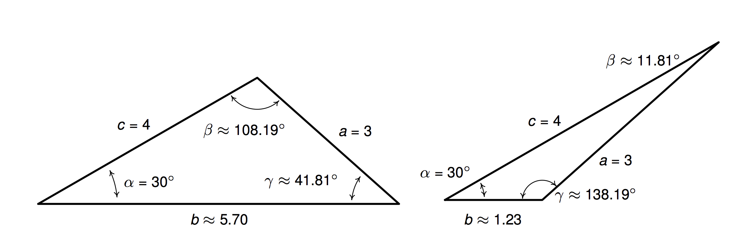

6)



Examples 3-6 show all cases of the following special case.

The Ambiguous Case SSA

You do not need to memorize cases. You just need to be aware that when you solve the trig equation for an angle, there may be one solution, two solutions, or no solution.

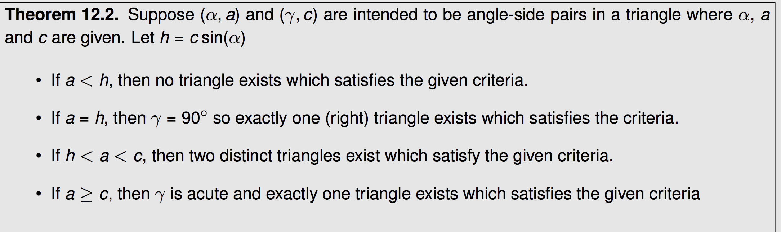

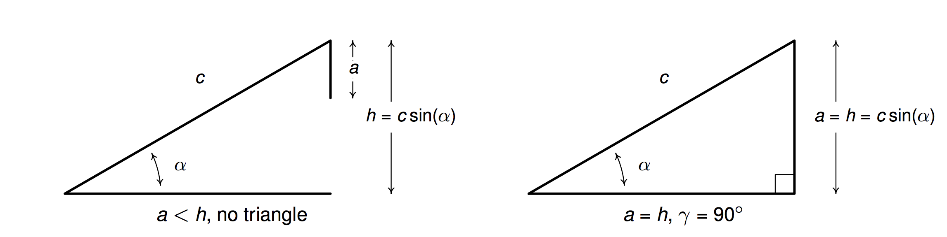

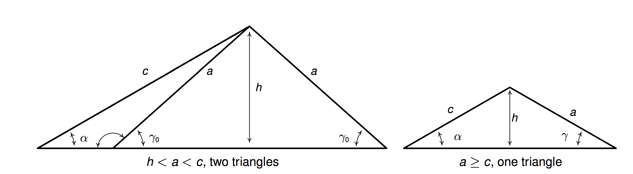

Application Problems:

Many problems we could do previously considering right triangles can now be done more directly using Law of Sines

A helicopter hovers 400 feet above a river. The angle of depression from the helicopter to the west bank is 73°, while the angle of depression from the helicopter to the east bank is 44°. (Remember, angle of depression is measured from the line of sight to the horizontal). Find the width of the river (exact and approximate.)



In physical problems, direction of travel is often given in bearings,

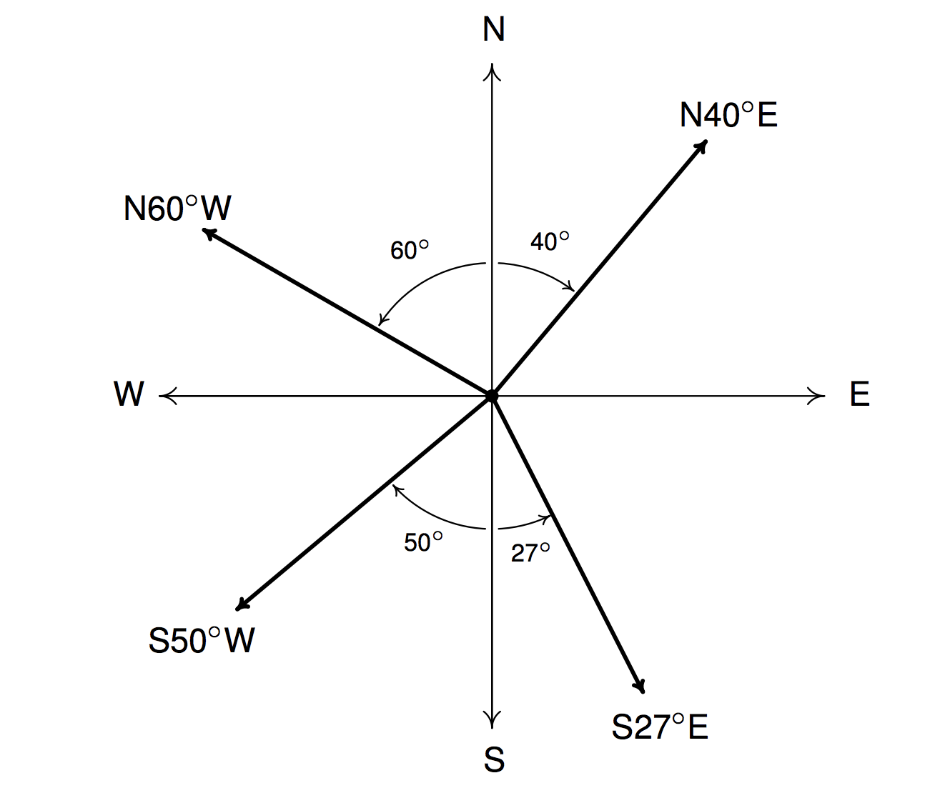

Example Bearings:

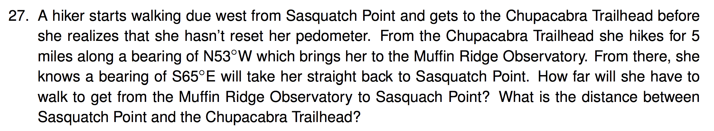

See book page 1032 for another example using bearings.

Example: Grade of hill (pg 1034)

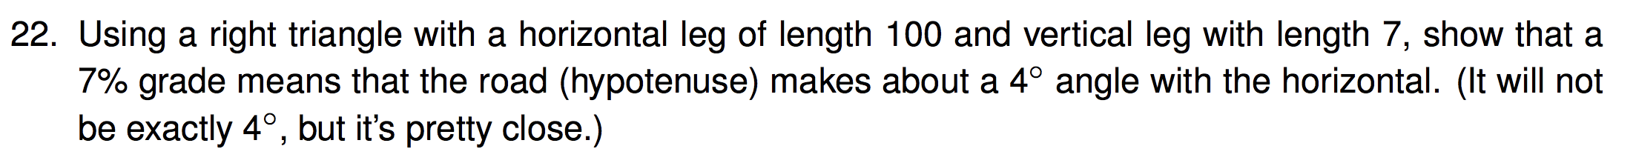

Application: Area of Triangle:

Suppose we are asked to find the area of the following triangle.

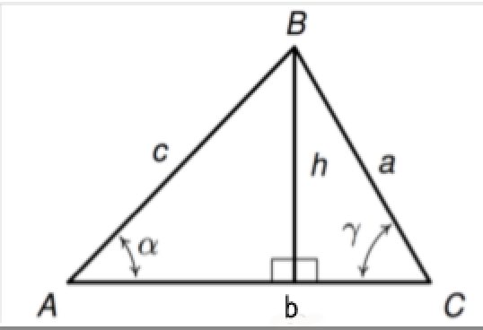

Area of the triangle is . But suppose we are given only . How would we find the area?

This leads to a new formula for finding area of a triangle when we know any two sides and the included angle (the angle between those two sides)

Example:

12.1 Law of Cosines

Example: Use the Law of Sines to find the remaining parts of the triangle given by



Development of the Law of Cosines

Can we find a relationship relating the sides of an oblique triangle? Suppose we superimpose a coordinate system onto a general triangle as shown.

What are the coordinates of point B? ___________________________

B

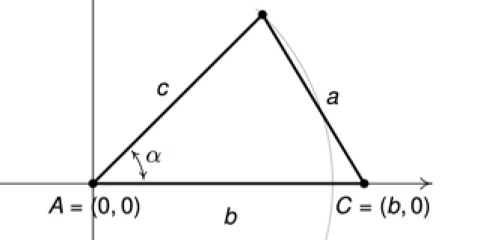

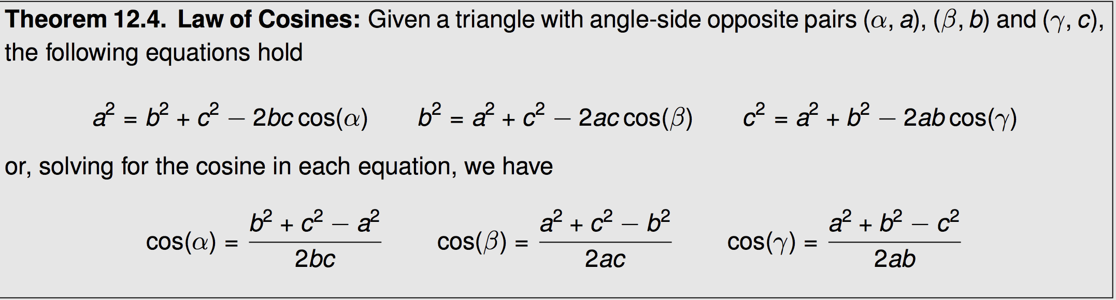

Note: you should not feel the need to memorize all 6 of these formulas! If you know the pattern of the first one, the rest follow.

Reconsider earlier Example: Find the remaining parts of the triangle given by



Tip: It is helpful to find the _________________________first.

(If we find the largest angle first, the others must be acute)

Example: Find remaining parts:



Example pg 1046

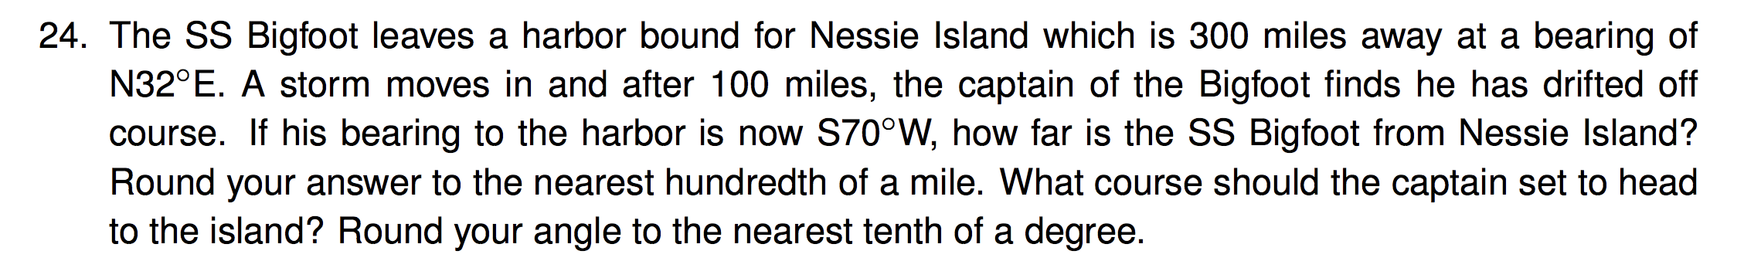

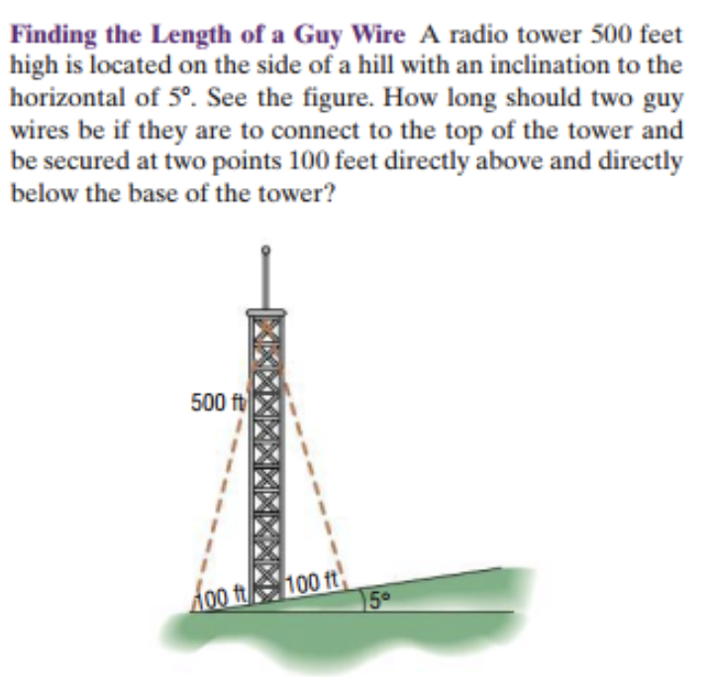

Law of Sines and Cosines Worksheet

*(note: answers have not been checked)*

(1) Two cars leave a city at the same time and travel along straight highways that differ in direction by 128°. If their speeds are 60mph and 50mph respectively, how far apart are the cars at the end of 20 minutes? (Exact and approximate.) *Approx ans: 33 miles*

(2) A man looks up and sees an airplane flying in his direction at a level altitude of 2 miles. He watches the airplane for a few minutes. During that period of time he notices that the angle of elevation to the airplane changes from 45° to 60° . How far has the plane traveled in that time?

Ans:  miles

(3)

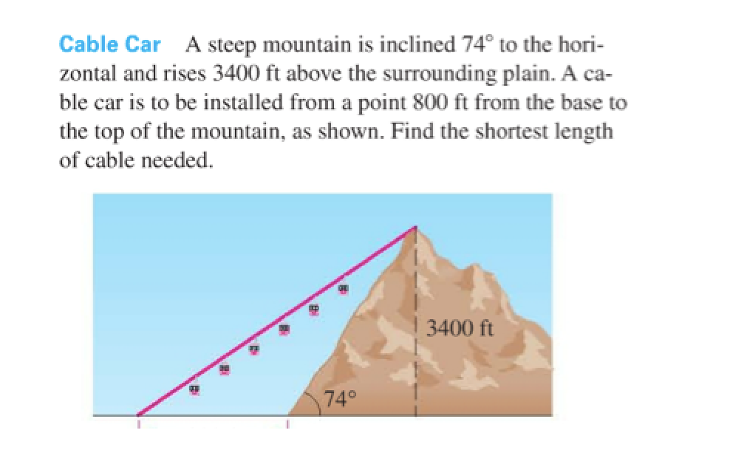

*approx ans:3835 ft.*

(4) If a tower is viewed from the top of a 50 foot building, the angle of elevation to the top of the tower is 59°. If viewed from the ground floor of the same building, the angle of elevation to the top of the tower is 62°. Find the height of the tower. (Show an exact answer and an approximate.)

ans:  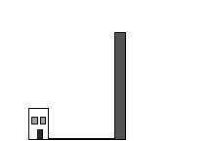

(5)

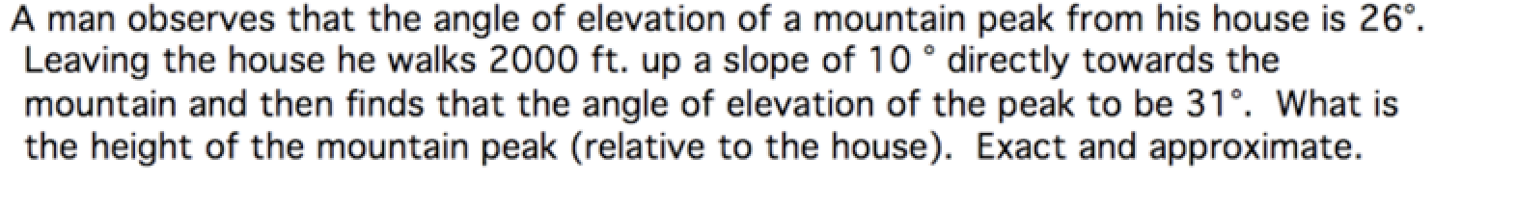 ans: 

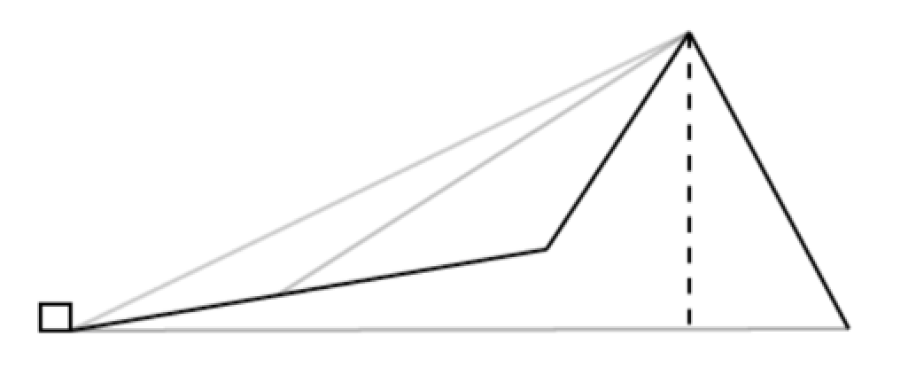

12.3 i Vectors

A vector is a mathematical object that allows us to represent both __________________ and

___________________. Vectors are often used physics and engineering.

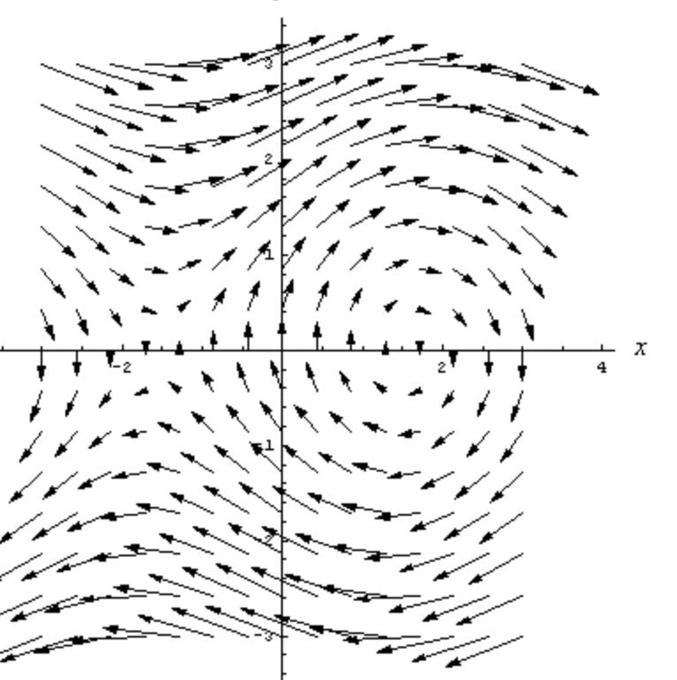

Geometric Representation of a vector:

Initial point, terminal point, notation, magnitude, direction, equal vectors

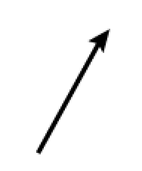   

Algebraic (Component) Representation of a Vector: Superimpose a coordinate system

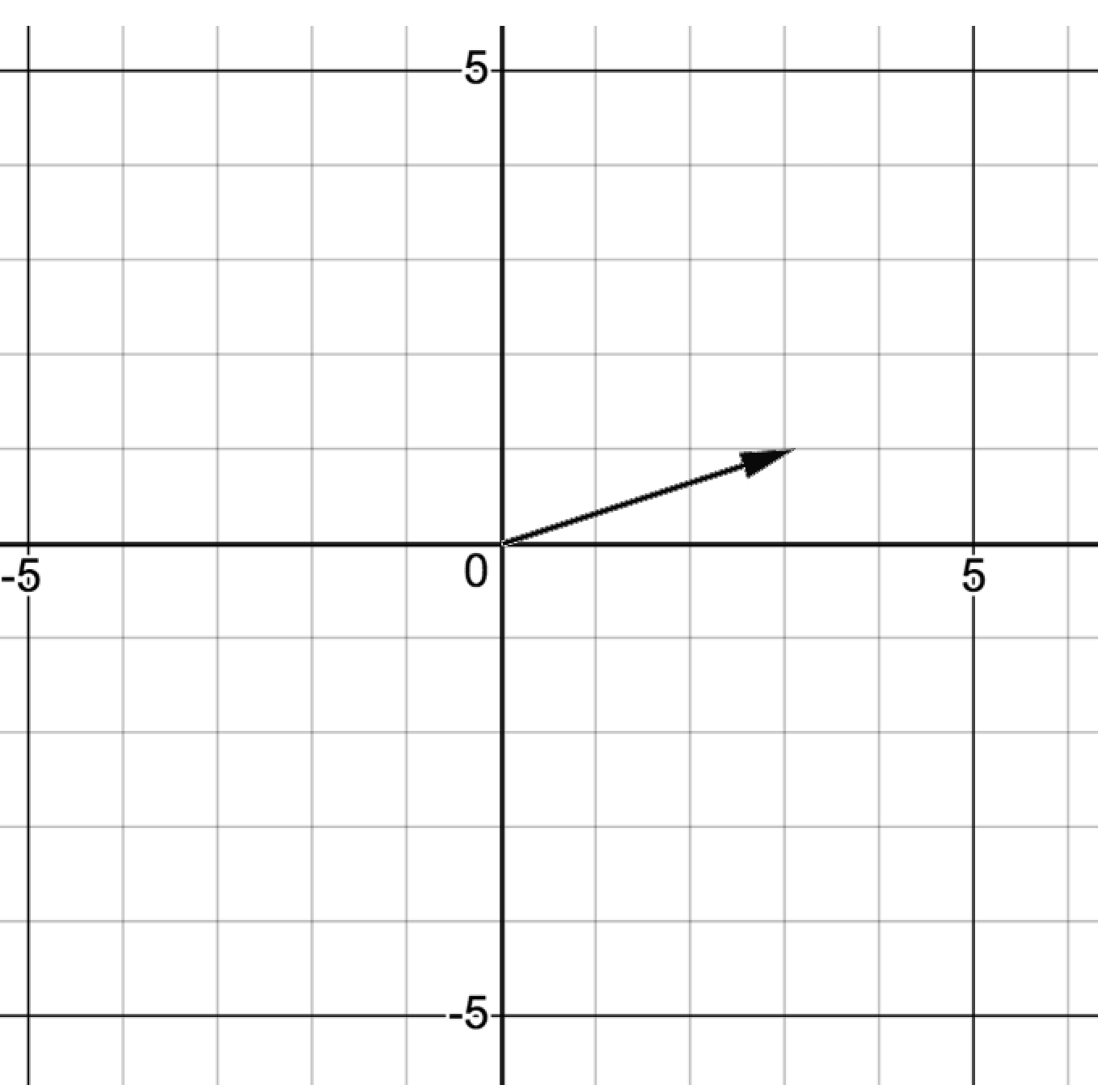 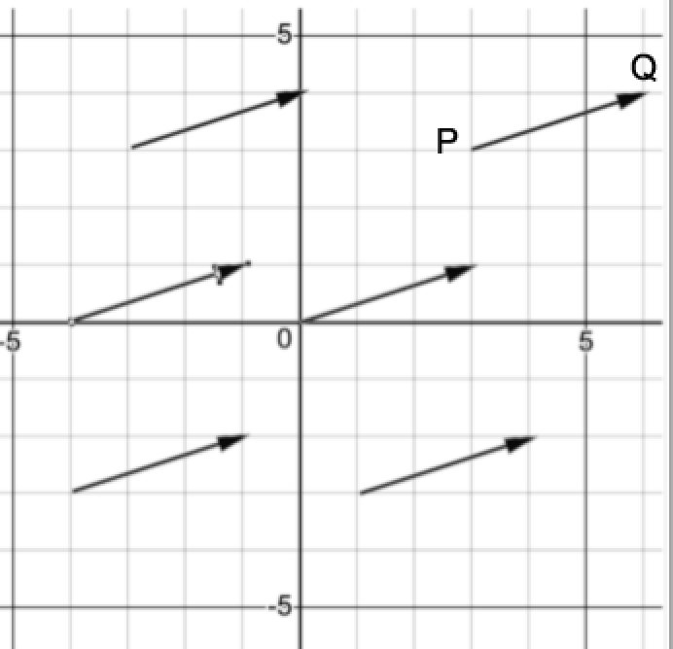

Computing the components of a vector  with representative  where the coordinates of points P and Q are given.

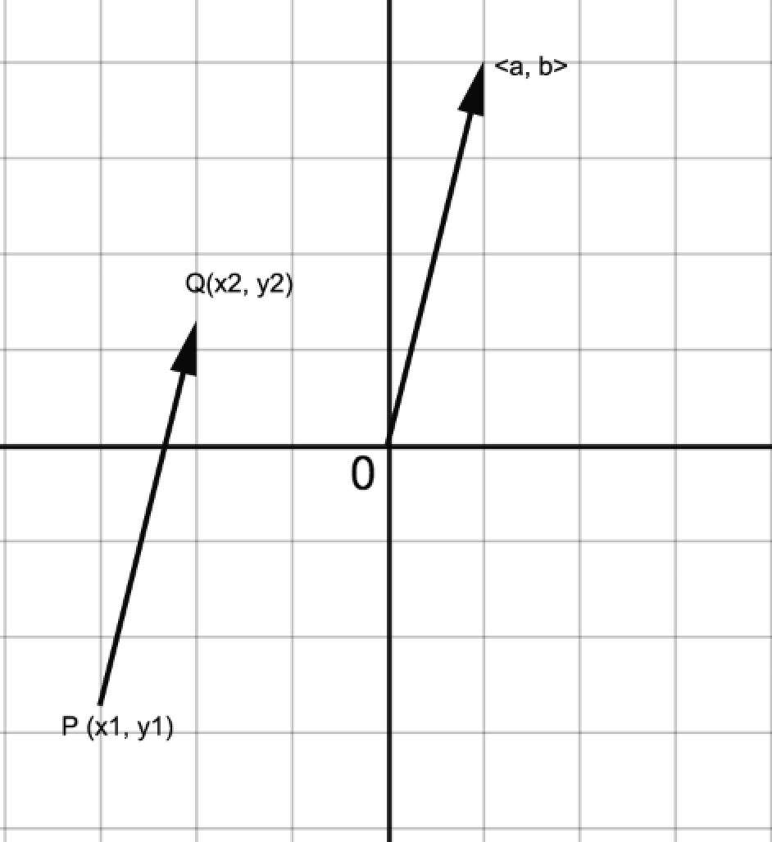 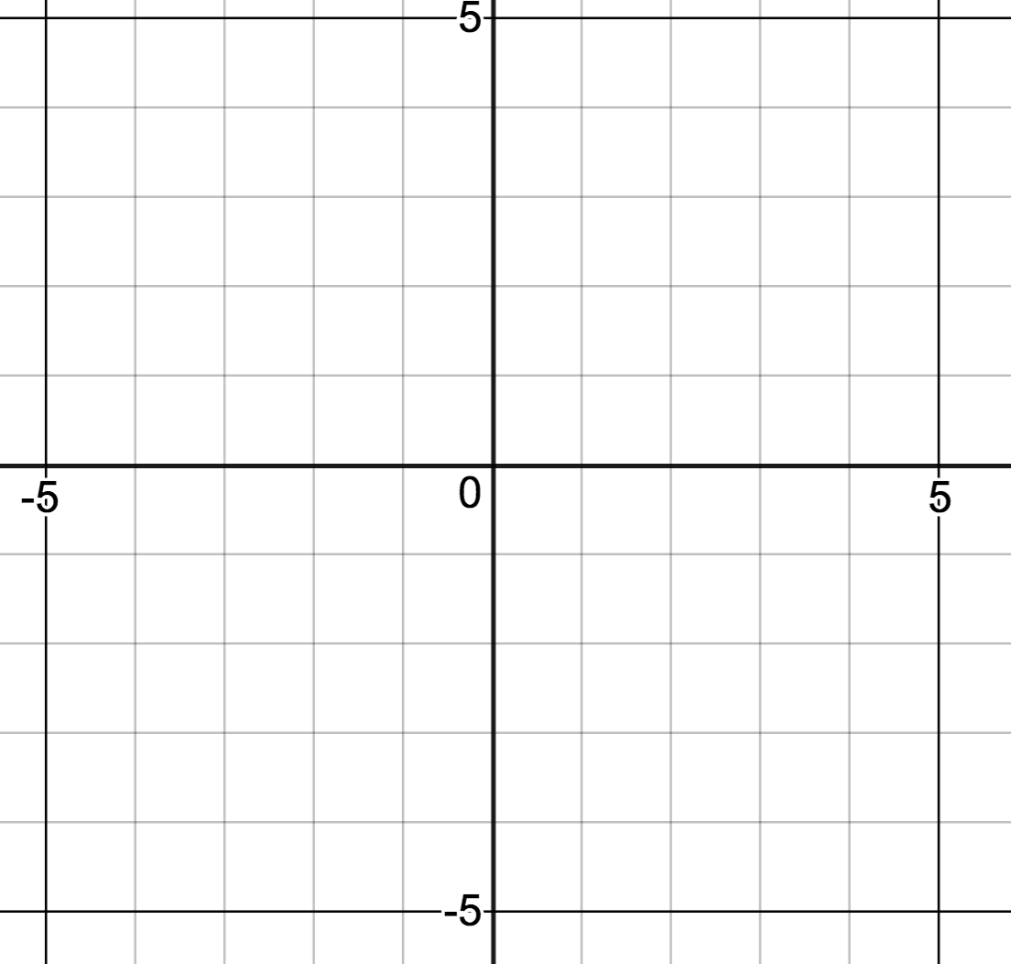

Converting: Magnitude/Direction to Component Form (if q in standard position)

Given  find ___________________

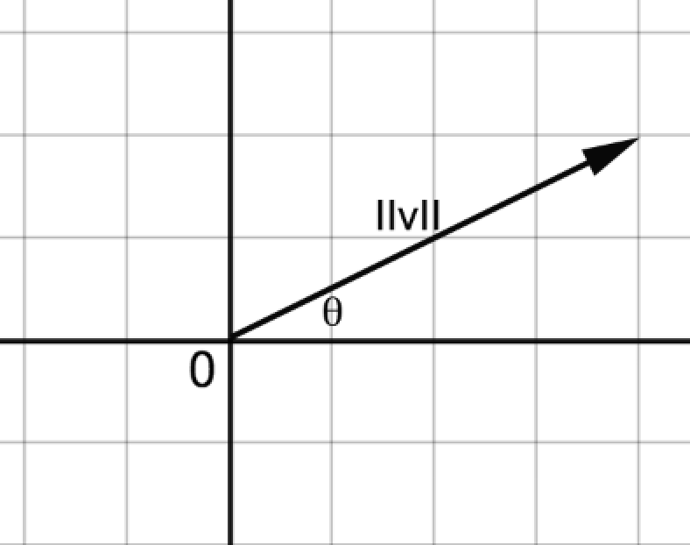

Examples:

 

Converting: Component Form to Magnitude/Direction Form

Given  find ___________________

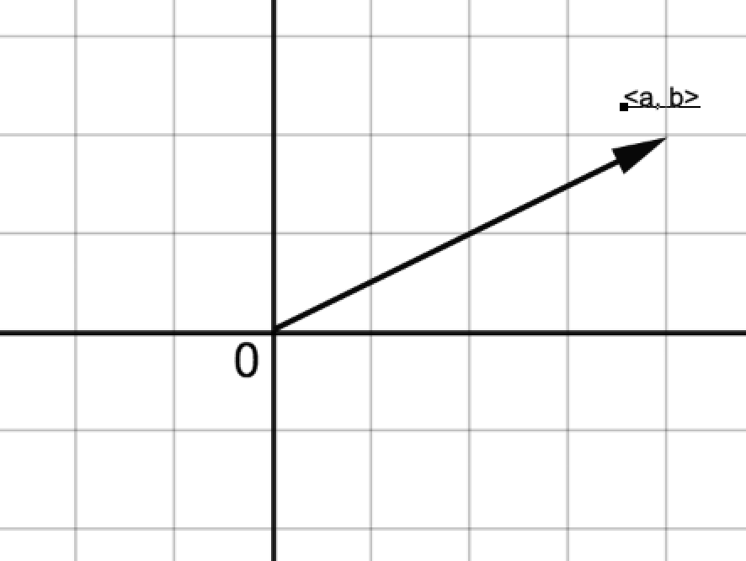 *** What quadrant is q in?

Examples:

  

Vector Operations

Addition Given , , how do we define ?

Geometric:

Tip-to-Tail Parallelogram

  

Addition (cont’d)

Algebraic Definition:

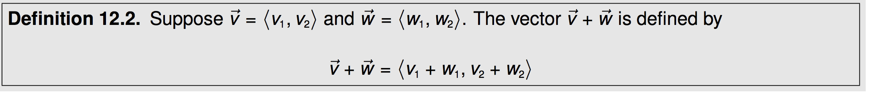

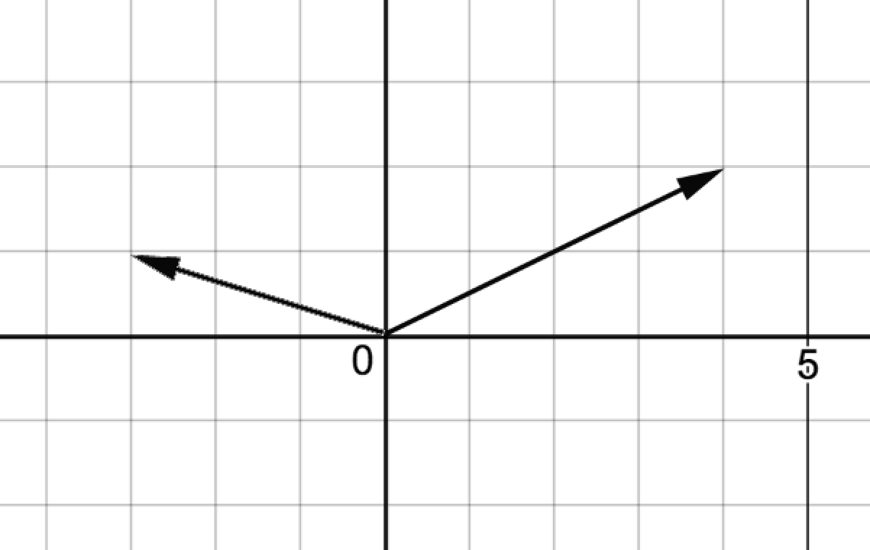

Example:

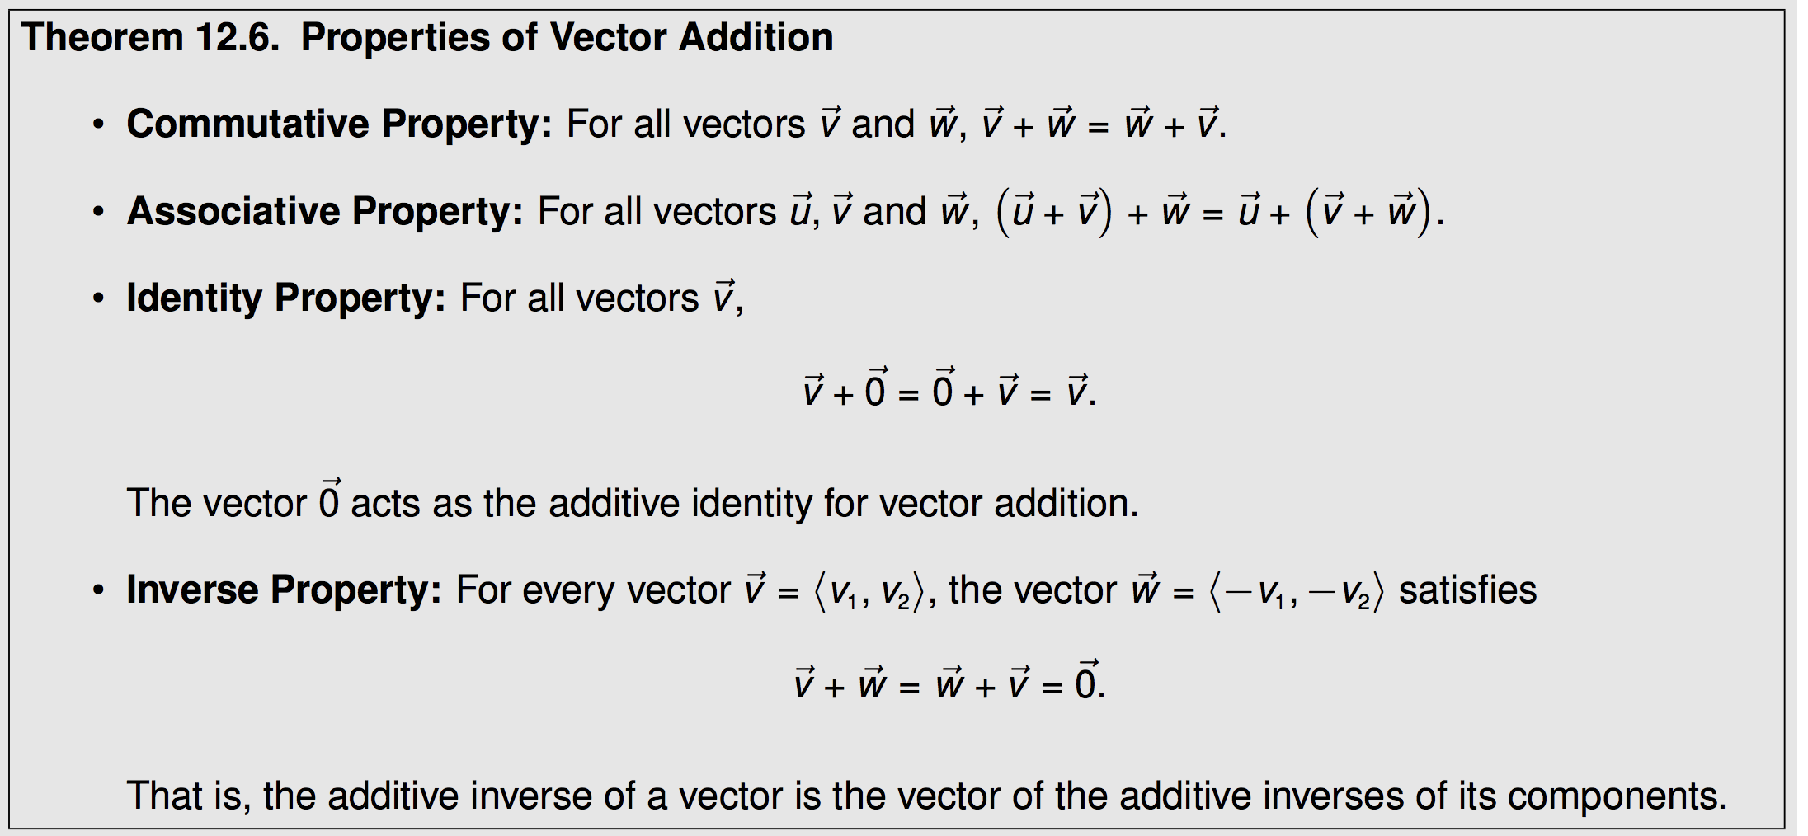

Zero Vector: _________________________

Proving Vector Properties:

Scalar Multiplication

Geometric:



Algebraic



Subtraction

Geometric: Adding Opposite Parallelogram

  

Algebraic:

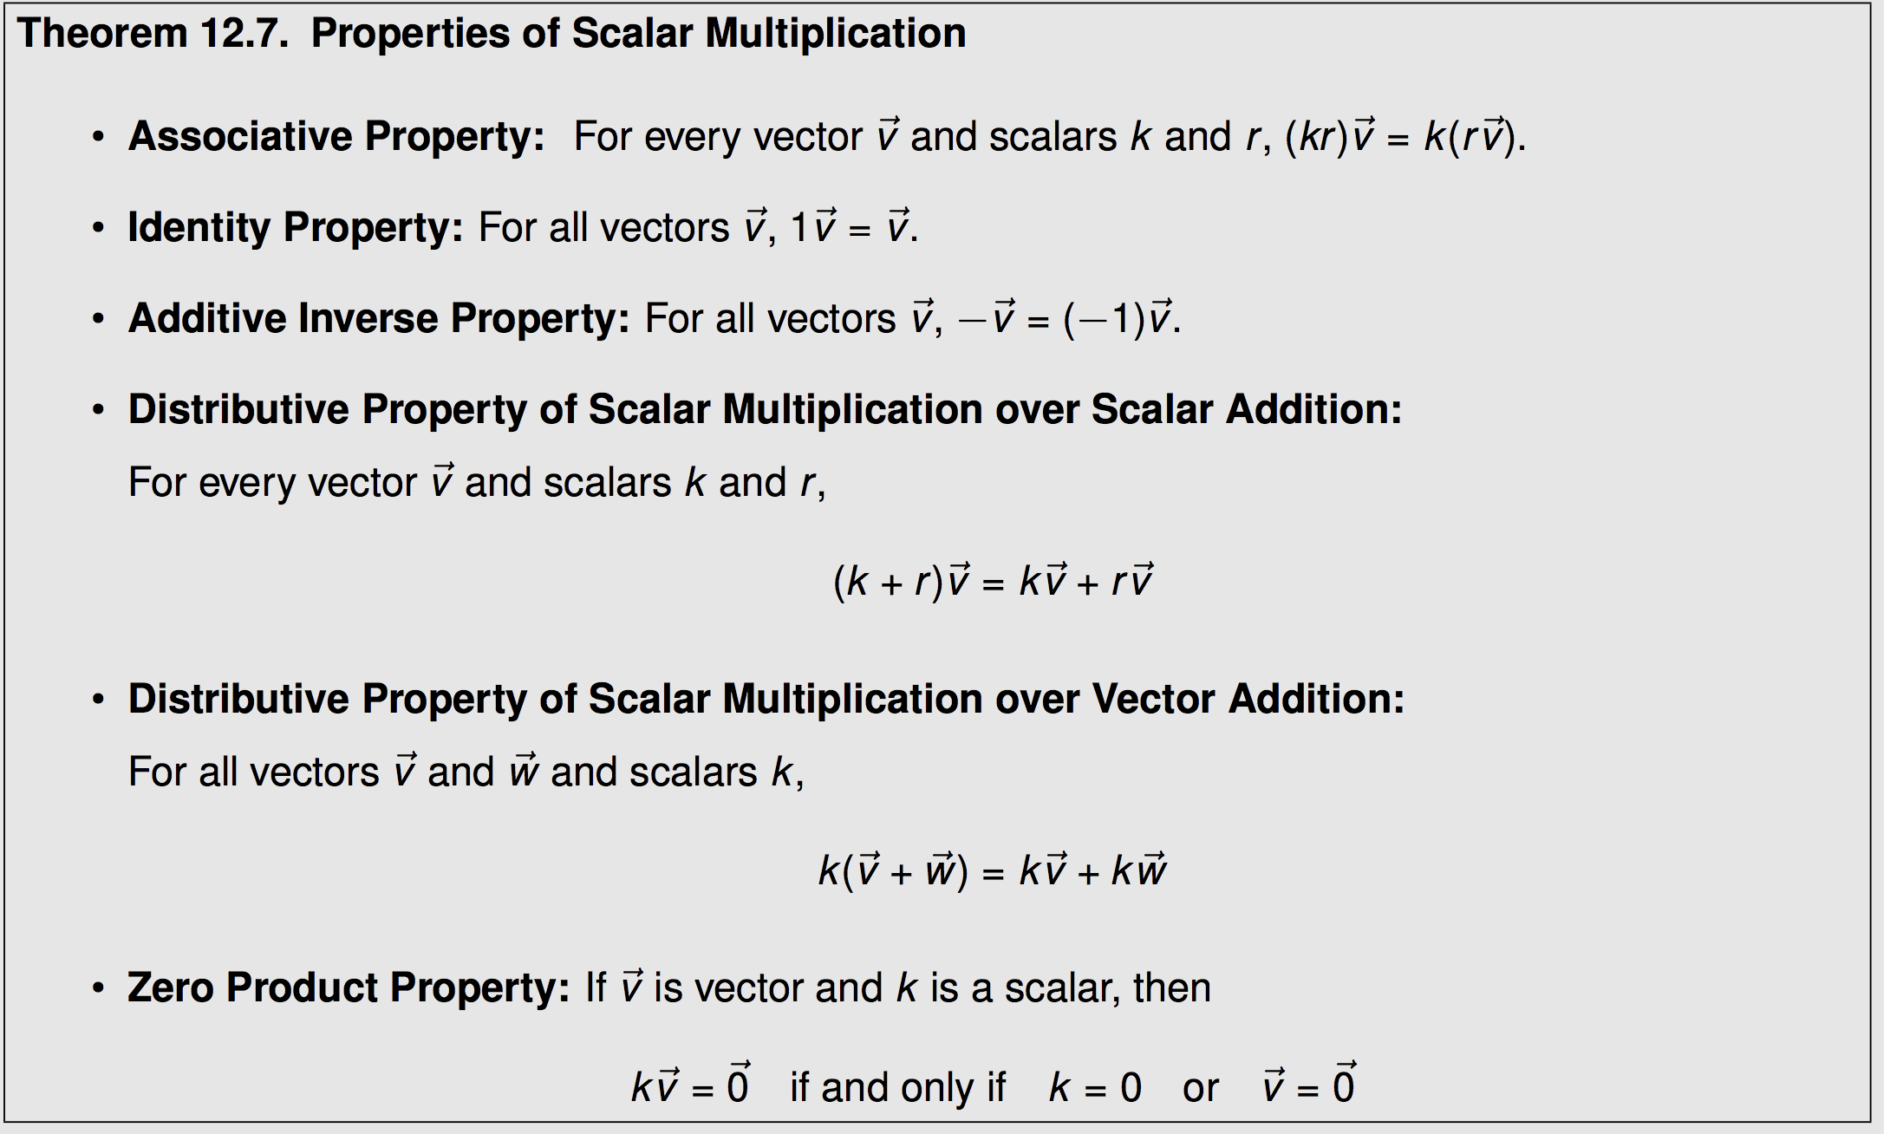

See example proof page 1055.

Unit Vector

A vector  is called a unit vector if  = ______________

Standard basis unit vectors: ______________ ______________

All vectors  can be written in the form 

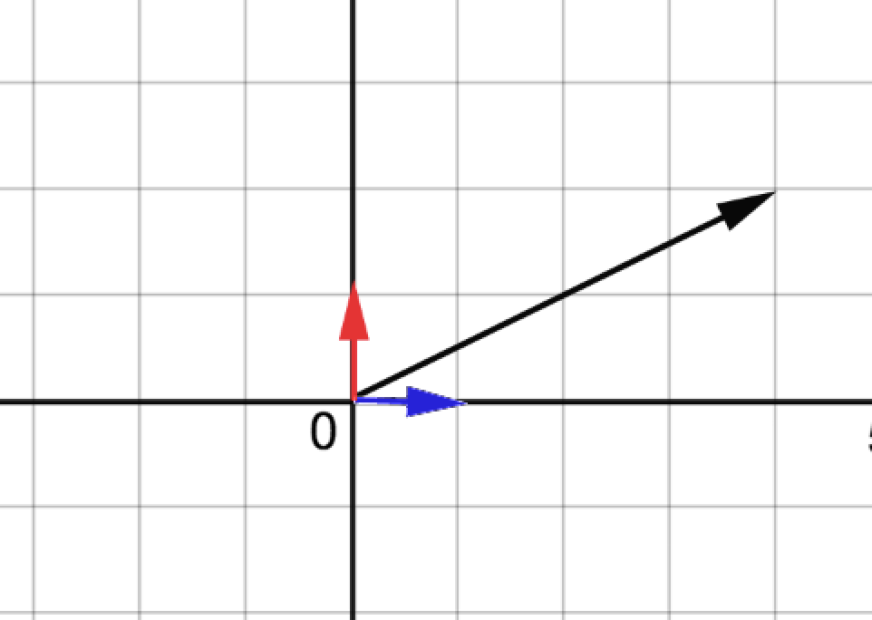

We are often interested to find unit vectors in a specified direction.

EX: Find a unit vector in the direction of 

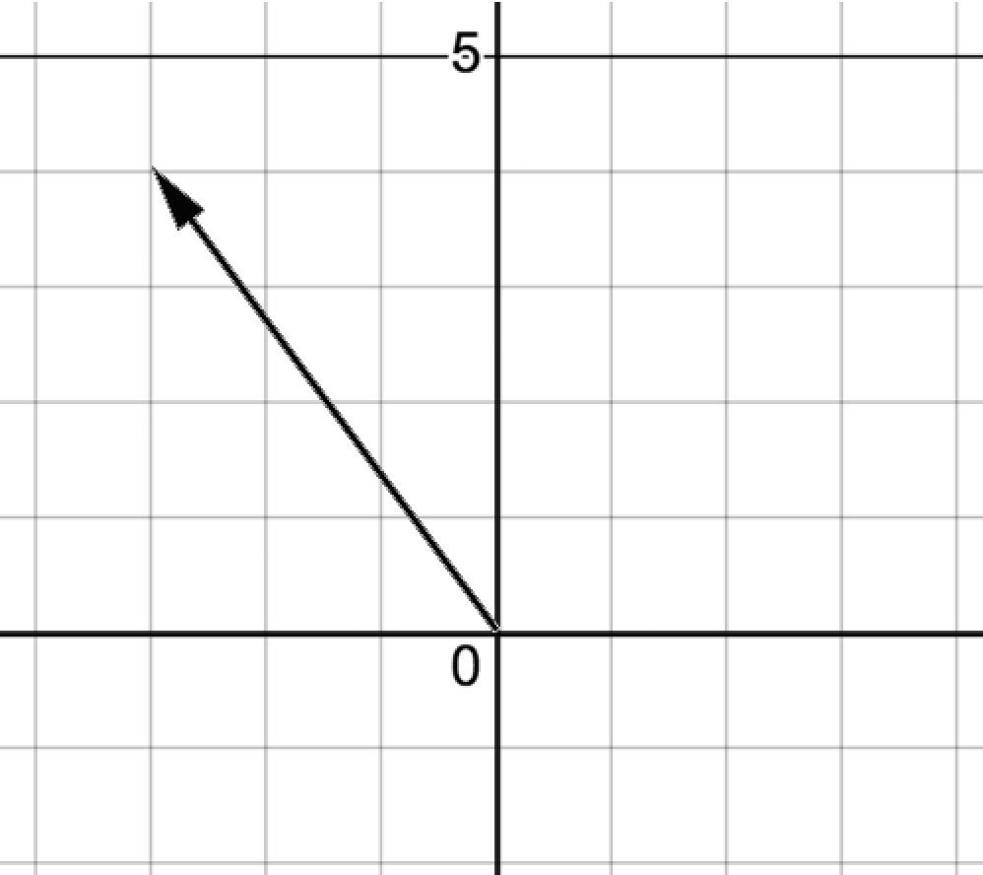

In general, a unit vector in the direction of  is given by _____________________________

EX: Find a vector of length 7 in the direction of 



12.3ii Applications – Resultants of Forces

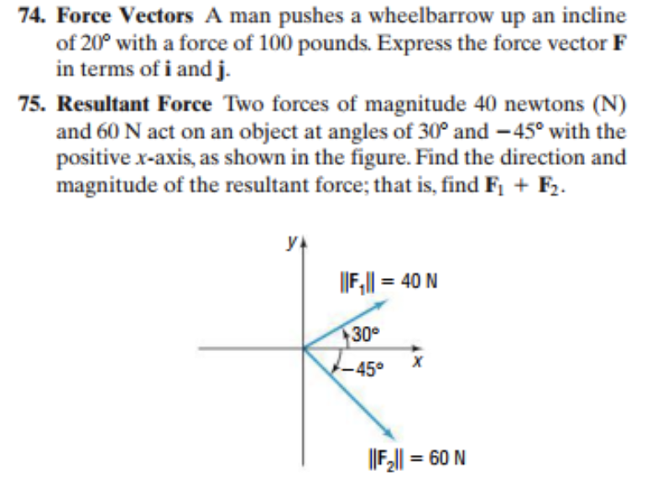



(page1059)



(page 1062)

*(note: answers have not been checked)*

Worksheet: Additional Vector Resultant Practice.

(1) Two forces act on an object as shown. Sketch the resultant. Find the magnitude and the direction of the resultant.(exact and approx.) *Ans:* lbs, 

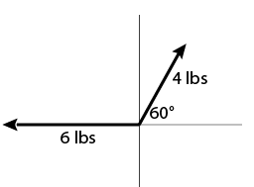

(2) Three forces act on an object as shown. Find the magnitude and the direction of the resultant.

*Ans:* lbs, 

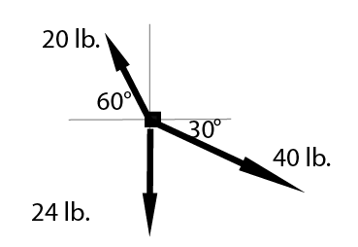

(3) An airplane is traveling at a constant airspeed of 500 mph in the direction N45°W. If wind is blowing directly northward at a rate of 40 mph, what is the actual speed and direction of the airplane?

*Ans:* Approx 190.4 mph,

12.4 The Dot Product (Scalar Product, Inner Product)

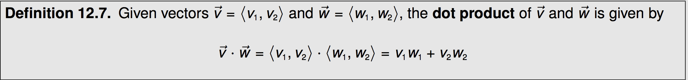

Examples:

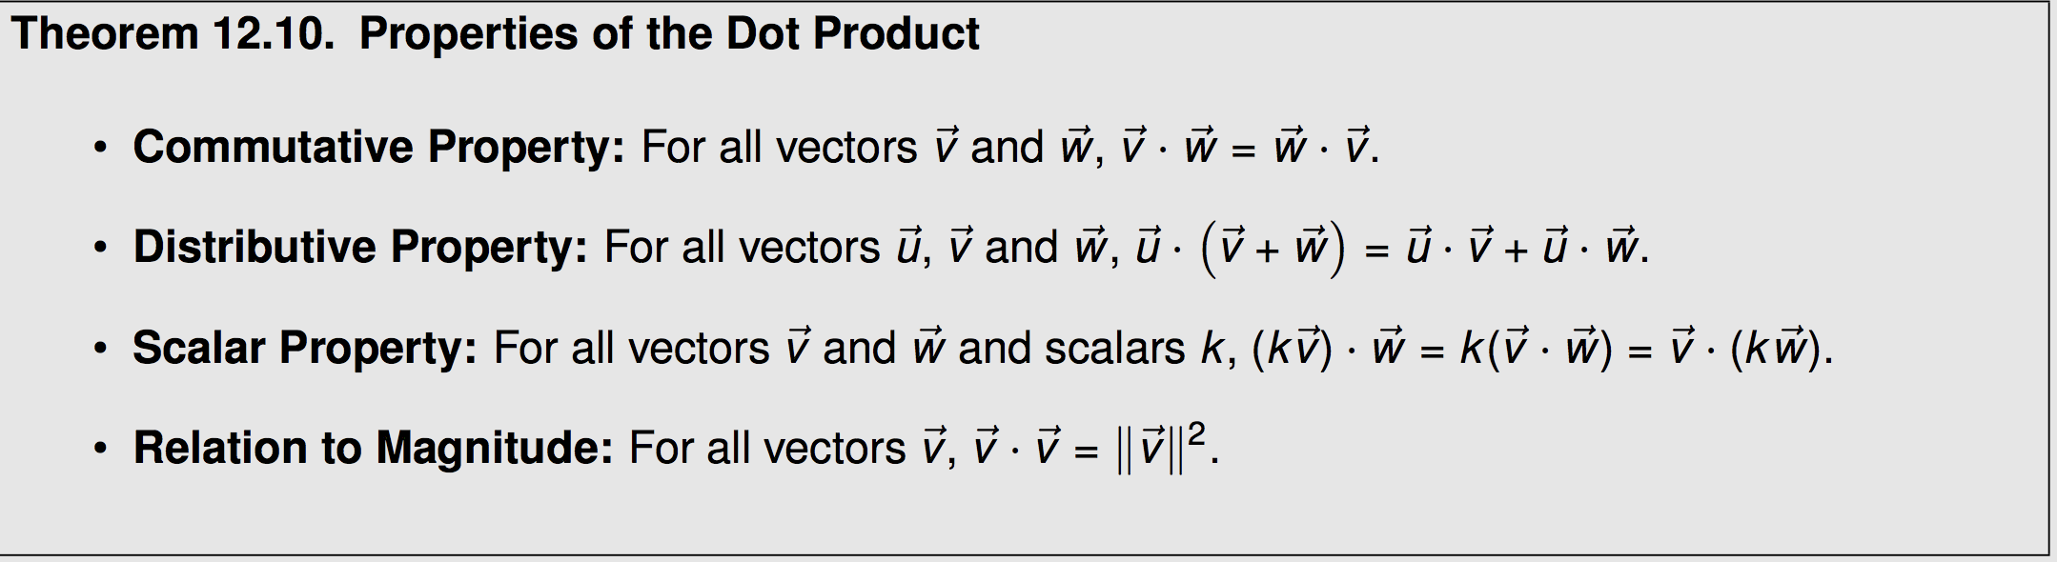

Example Proof

Applications of Dot Products.

Seemingly unrelated problem: Find “the angle” between two vectors





Example: Find the angle between

a)  b)  c) 

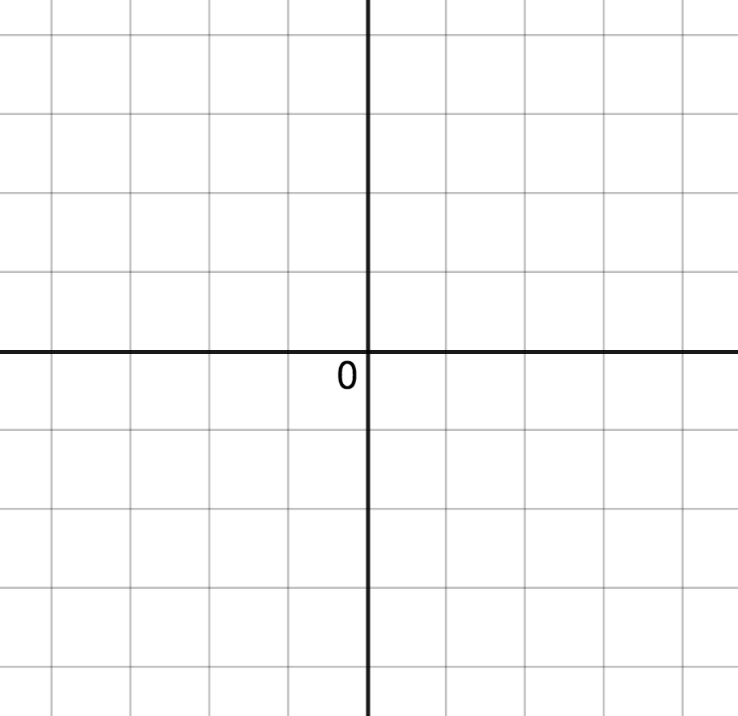  

  

Another way to find the dot product, depending on what info you are given.

Example: Find **v** • **w**

given the vectors **v** and **w** as shown, with the angle between **v** and **w** equals 60°,

II**v**II =5

II**w**II =3

Orthogonal Projections

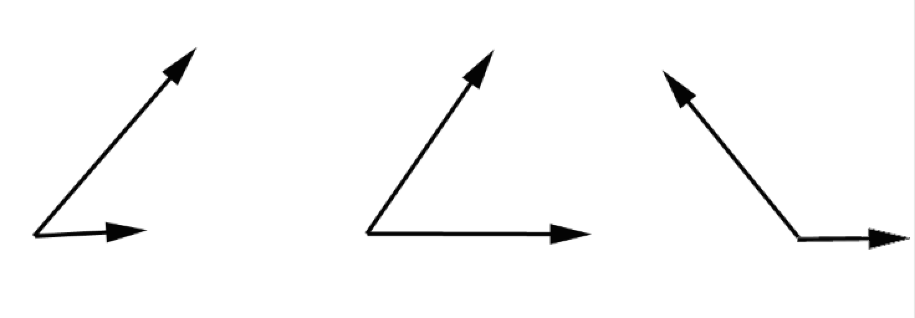 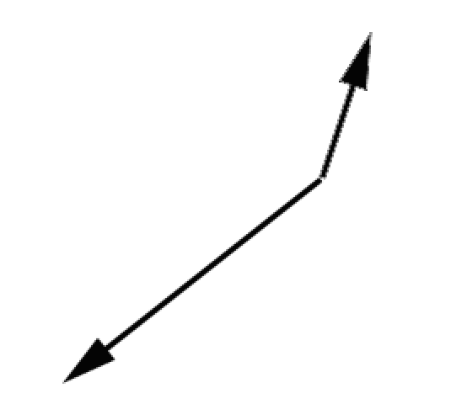

Derivation of the formula for finding the projection of  onto  , 

First notice that is either in the direction of  or in the opposite direction, thus

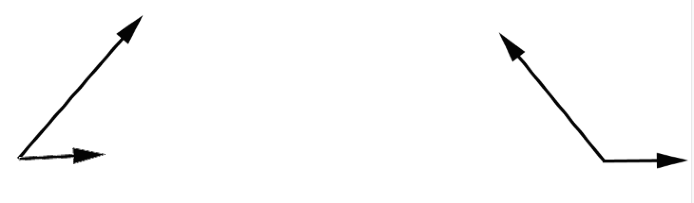

=_______________ or =________________

Suppose we knew the length of the projection, call it L. (L= ). Then similar to the example on page 22,

=_______________ or =________________

Now let’s find L

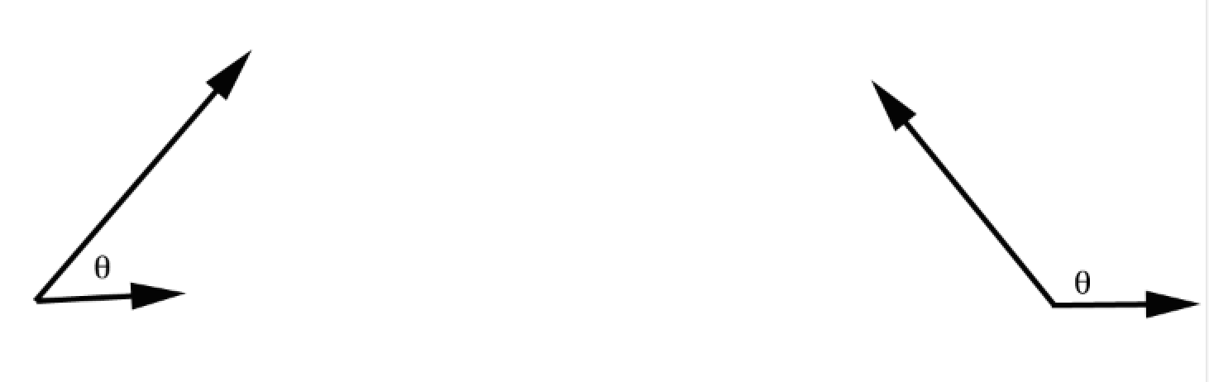

____________________ ____________________

____________________ ____________________

so as a dot product,

____________________ ____________________

=_______________ or =________________

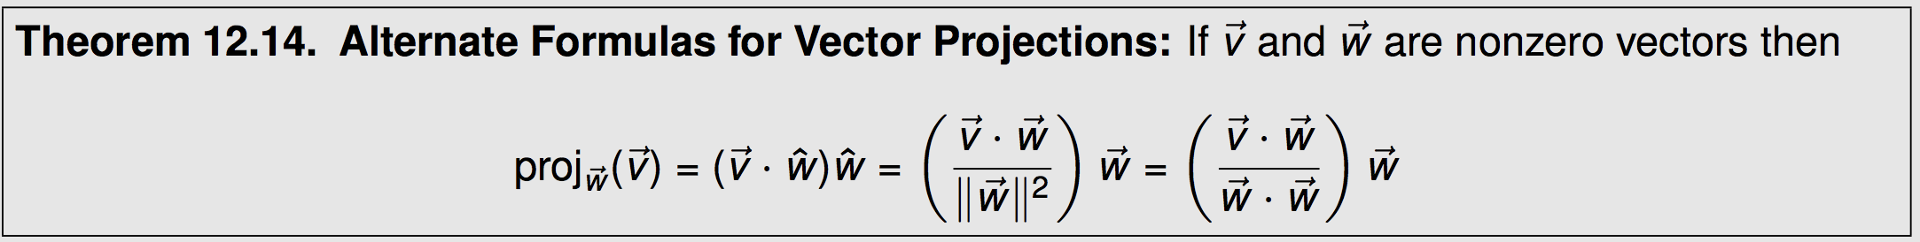



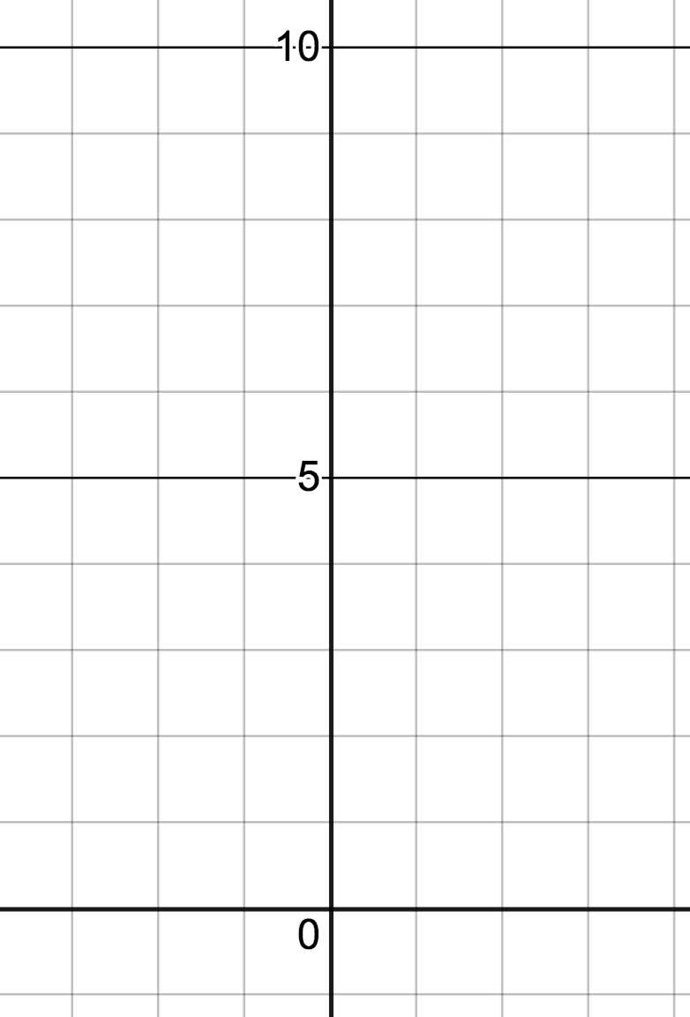

Orthogonal Vectors/ Parallel Vectors

If  and  are orthogonal, then _________________________

If  and  are parallel, then _________________________

Ex: Are the vectors  and  orthogonal?

Ex: Are the vectors  and  orthogonal?

Ex: Find x such that  and  orthogonal.

Ex: Are the vectors  and  parallel?

Work

In physics, if a constant force F is exerted over a distance d, the work W done by the force is given by W=Fd. Here the assumption is that the force being applied is in the direction of motion.



If the force is applied not in the direction of motion, we need to determine how much of the force is in the direction of motion.

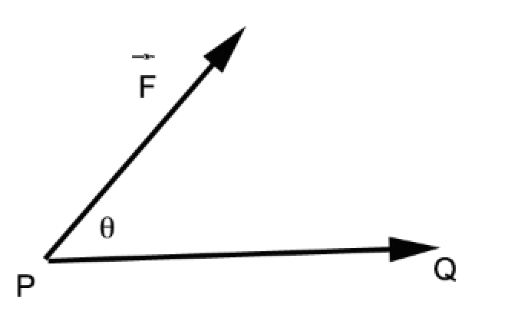

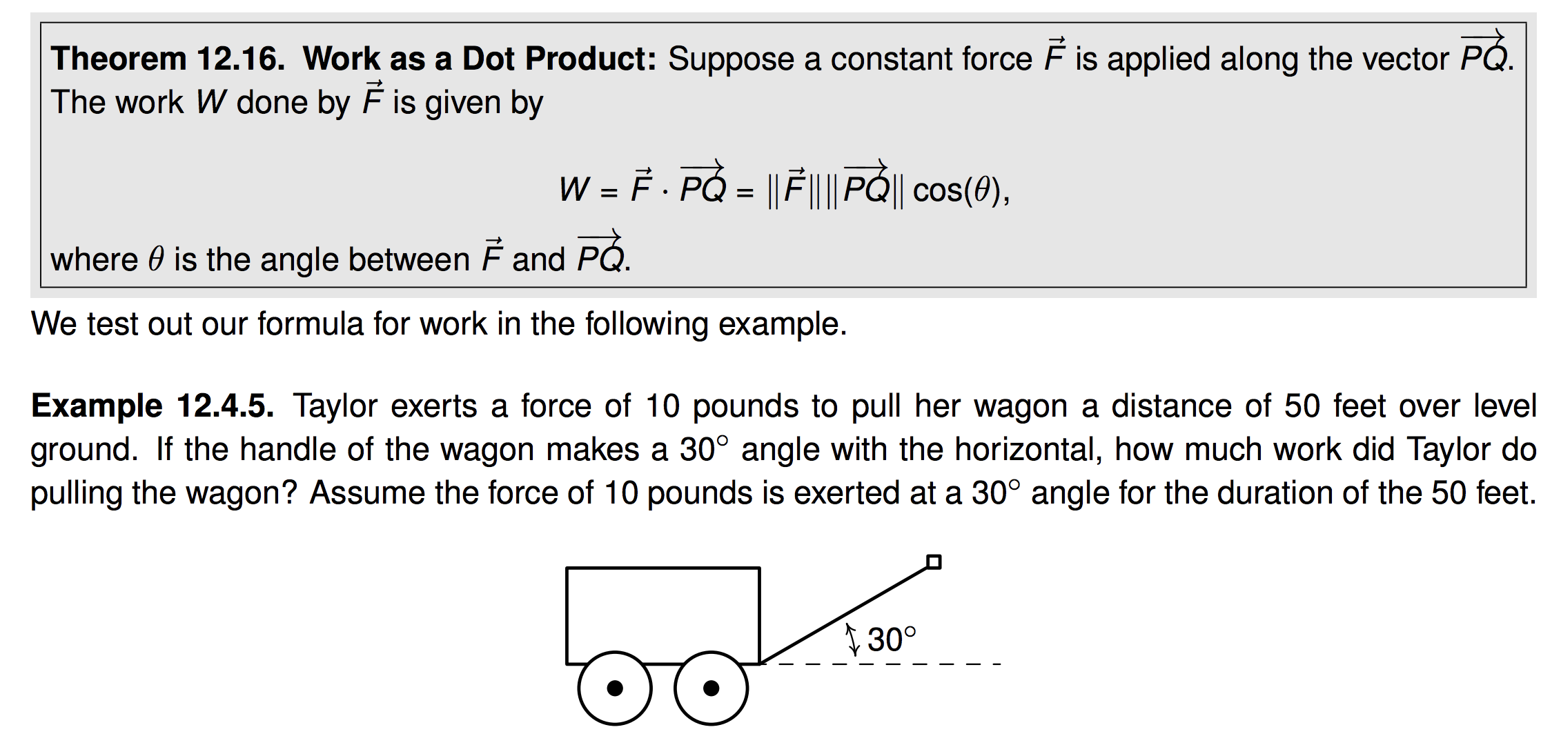

13.1 Polar Coordinates

Up until now, we have used Cartesian or Rectangular Coordinates to locate a point in two dimensions. Here we will discuss a new way.

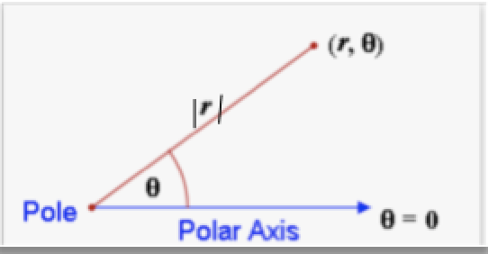

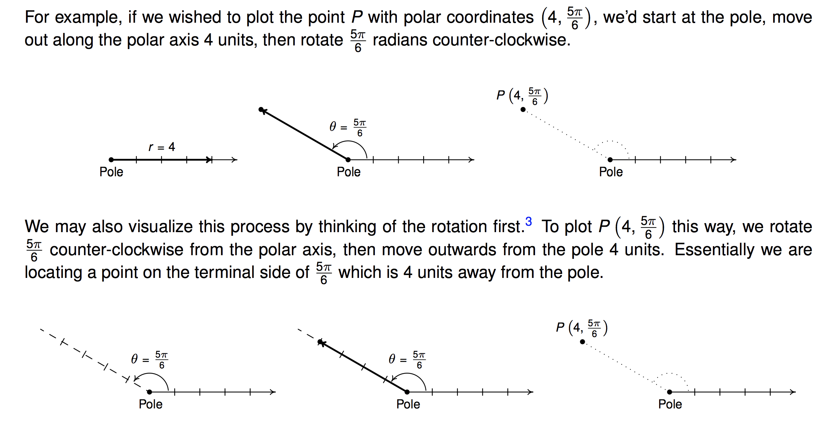

We can approximate such a point on rectangular graph paper or we can use polar graph paper.

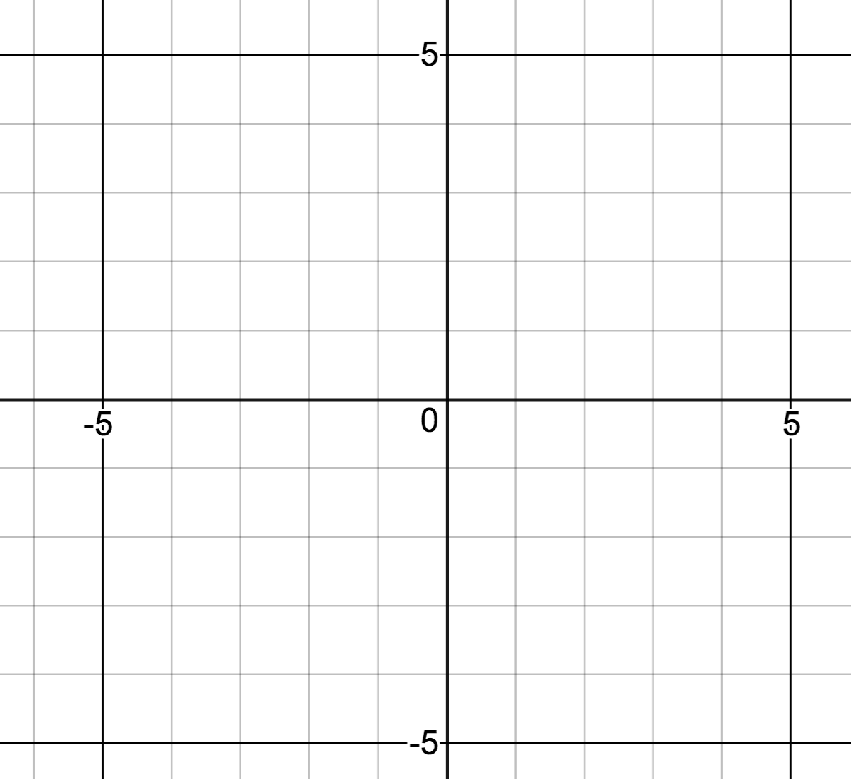 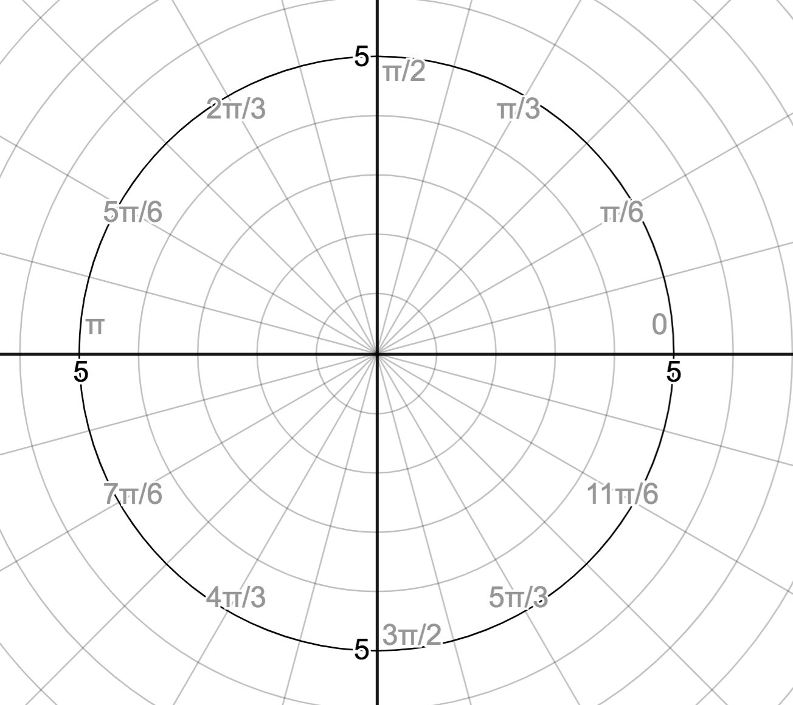

Example: Plot the polar points:



Note, representation of polar points is not unique.

What if r<0? Plot the polar points :



Often we are asked to find other representations of a given polar point.

Example: Find two other representations of the polar point _____________, one with r>0 and one with r<0.



Converting Points

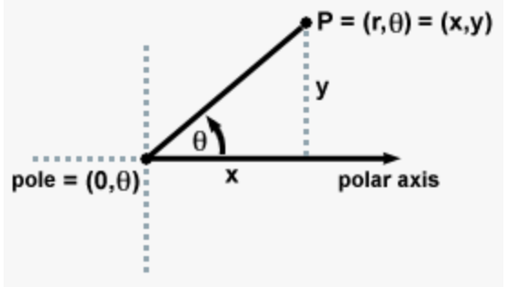

Polar to Rectangular Rectangular to Polar

Converting Equations

 

Polar to Rectangular Rectangular to Polar

See Text page 1095 for more examples

13.2 Graphing polar equations

The more we work with polar graphs, the more we will recognize the equation of basic polar graphs and be able graph them more efficiently. Here are some strategies we can use.

1) Do we recognize the equation? If so, use that knowledge to graph quickly.

2) Try converting the polar equation to rectangular to see if it is a known graph.

3) Use an auxiliary rectangular graph.

4) Last resort, plot points.

Example: 



Example: 



Example: 

OFFSET CIRCLE



Ex: Graph  now that we recognize this type of equation.

Example: 

Convert:

Plot points:

Auxiliary Rectangular Graph: (like plotting points but more info and quicker)

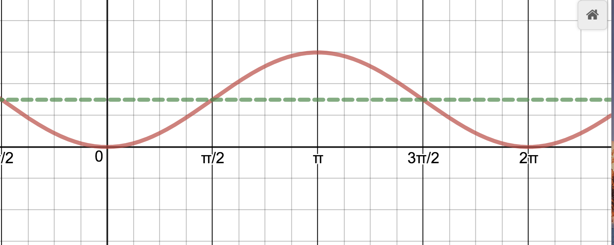

Polar Graph:

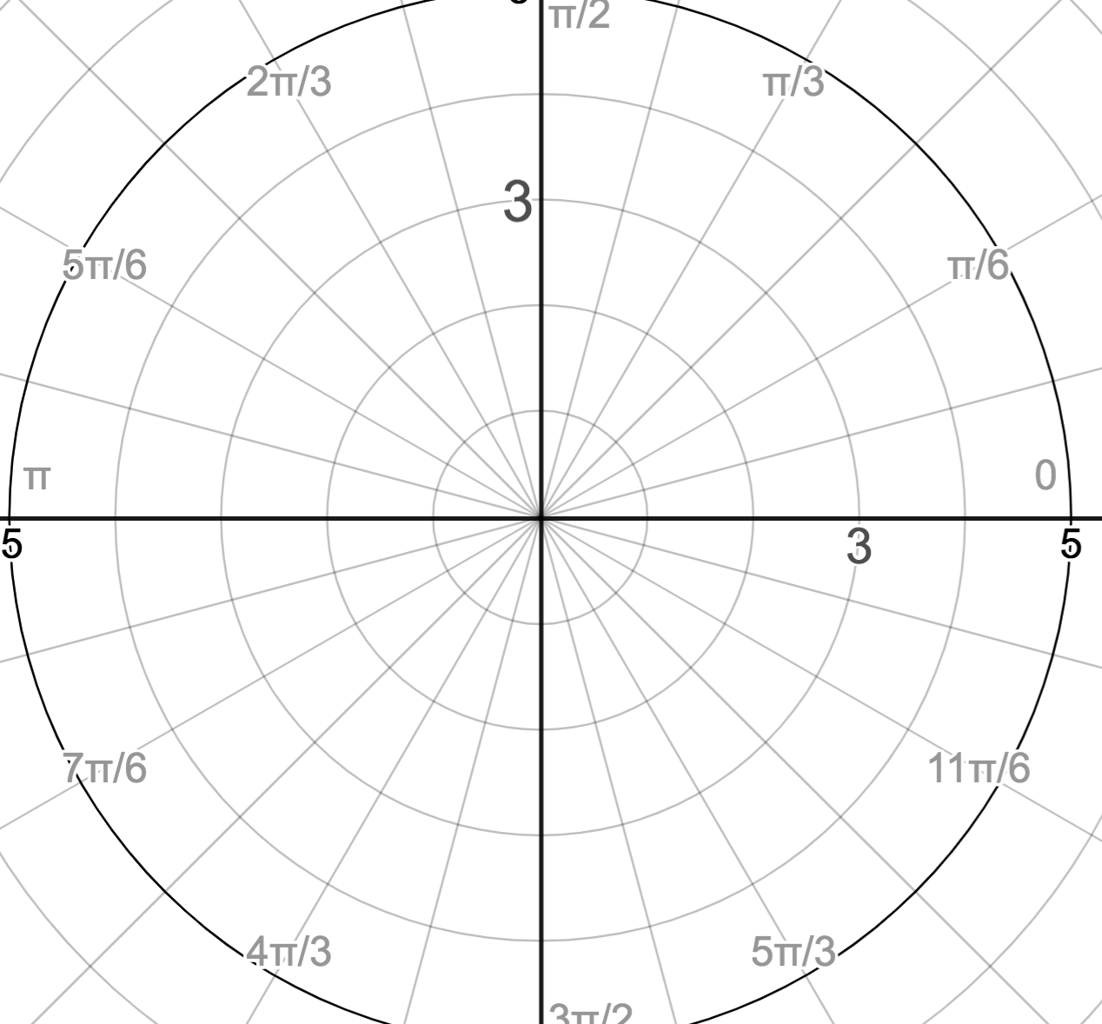

See Polar Cardioid demonstration on Math 8 page and Polar Grapher Geogebra (set view to change)

CARDIOID



Ex: Graph  now that we recognize this type of equation.



Example: 

Convert: (try it….doesn’t help)

Auxiliary Rectangular Graph: (like plotting points but more info and quicker)

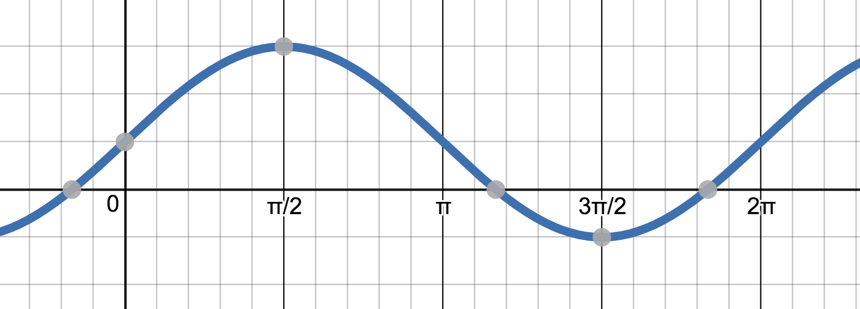

Polar Graph:



See Polar Cardioid demonstration on Math 8 page and Polar Grapher Geogebra

LIMACON



See Limacon demo, Polar Grapher Geogebra and Desmos Limacon Cardioid on Math 8 page.

Example: 

Convert: doesn’t help.

Auxilliary Graph:

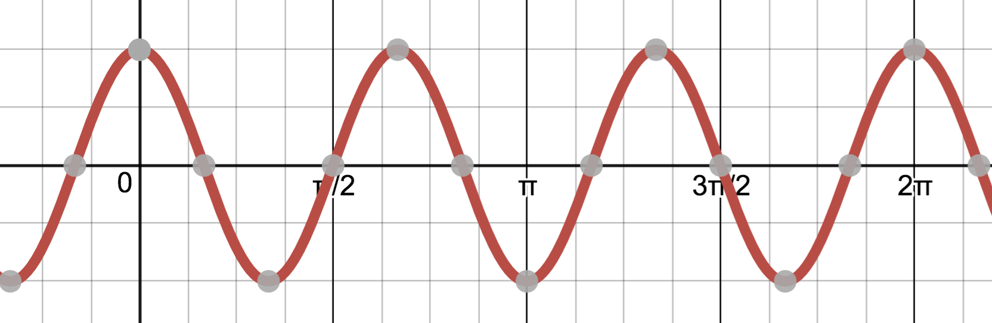

How would we find the “x intercepts” and highs and lows? What do they correspond to on the polar grapjh?

Polar Graph

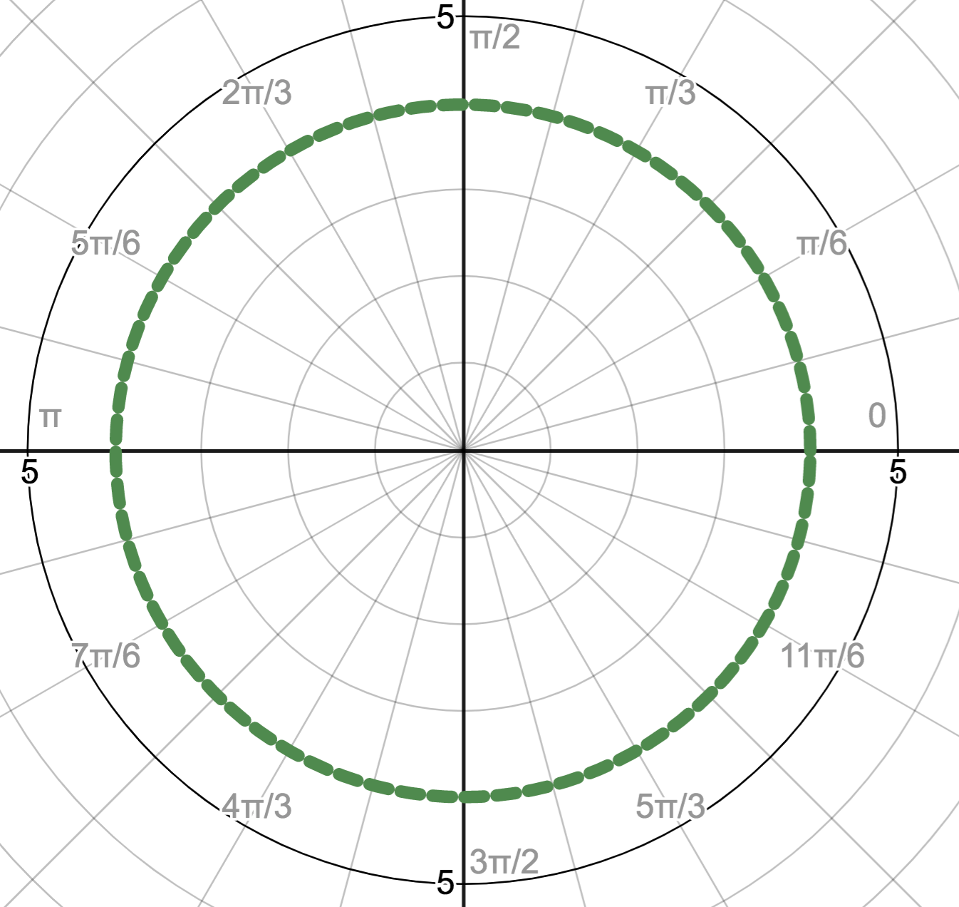

See Polar Grapher geogebra for n even vs n odd.

ROSE



If we recognize that we have a rose graph, there are shortcuts to finding the graph.

How many petals? 

How long are the petals? ________________________________

How far apart are the petals spaced? ___________________

How can we find the location of one petal? __________________________________

(Same as finding highs and low of rectangular graph)

Ex: Graph  using shortcuts.

